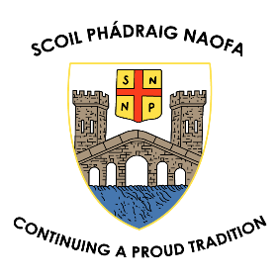
ANNUAL ADMISSION NOTICE
in respect of admissions to the 2024/2025 school year

Admission Policy and Application Form
A copy of the school’s Admission Policy and the Application Form for Admission for the 2024/2025 school year is available as follows: –
To download at: www.spnbandon.com
On request: By emailing: office@spnbandon.com
In writing to : Scoil Phádraig Naofa, Convent Hill, Bandon, Co. Cork.
*Applications for our special classes are made using the same form and ticking the appropriate class

PART 1 - Admissions to the 2022/2023 school year

Application and Decision Dates for admission to 2024/2025
The following are the dates applicable for admission to all classes in the school

The school will commence accepting applications for admission on | October 1st 2023
The school shall cease accepting applications for admission on | February 1st 2024
The date by which applicants will be notified of the decision on their application is | February 22nd 2024
The period within which applicants must confirm acceptance of an offer of admission is | March 7th 2024

- Failure to accept an offer within the prescribed period above may result in the offer being withdrawn.
- The school will consider and issue decisions on late applications in accordance with the school’s admission policy.

Special Class Application and Decision Dates for admission to Scoil Phádraig Naofa
The following are the dates applicable for admission to the school’s Special Classes which cater for children with ASD -
The school will commence accepting applications for admission to the special class on | October 1st 2023
The school shall cease accepting applications for admission to the special class on | February 1st 2024
The date by which applicants will be notified of the decision on their application for admission to the special class is | February 22nd 2022
The period within which applicants must confirm acceptance of an offer of admission is | March 7th 2022
*Failure to accept an offer within the prescribed period above may result in the offer being withdrawn

Number of places being made available in Scoil Phádraig Naofa

The number of places being made available in junior infants is | 28
The number of residential places is (boarding schools only) | N/A
The number of non-residential places is (boarding schools only) | N/A
The number of places being made available in the special class* catering for children with ASD is | Primary – 5  Early Years - 6

PART 2 - Admissions to the 2023/2024 school year
Information regarding the admission process for the Intake Group for ASD Class for the 2023/2024 school year

In respect of the 2023/2024 school year, the total number of applications for admission received by the school was 12
Breakdown of places allocated for the 2023/2024 school year:
Number of places available: | 7
Number of applications received: | 12
Number of Offers made and accepted under each criteria: | Children within Bandon Parish: 7 offered, 7 accepted
Total number of offers made | 7
Number of names placed on waiting list for the school year concerned. | 7

